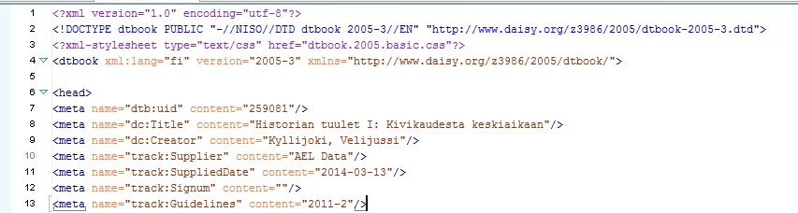
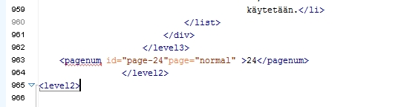
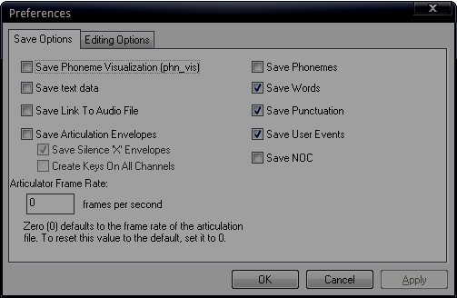
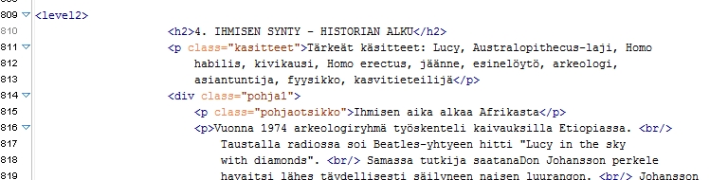
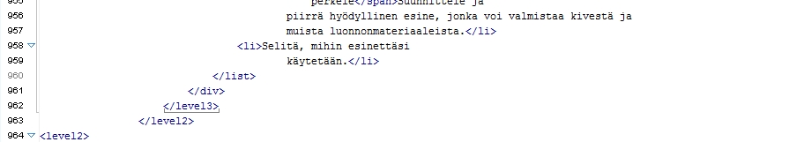
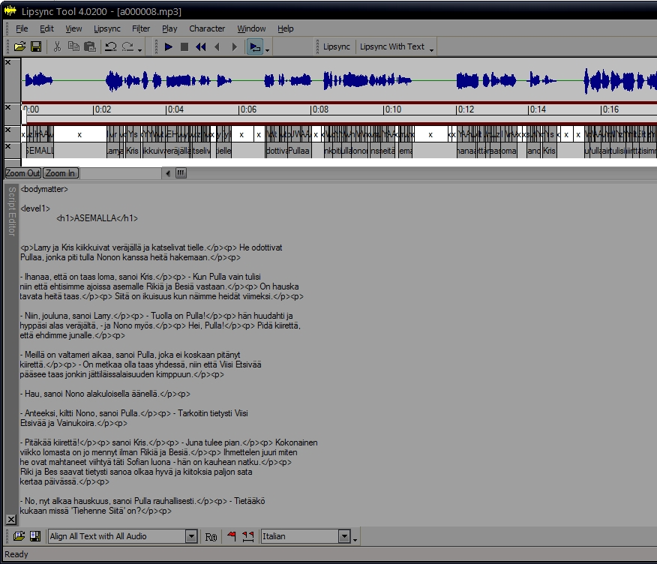
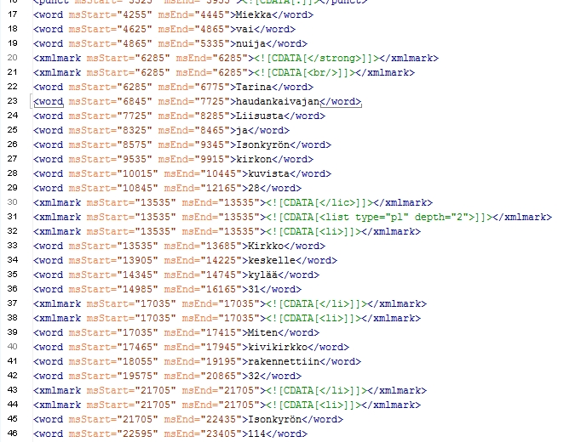
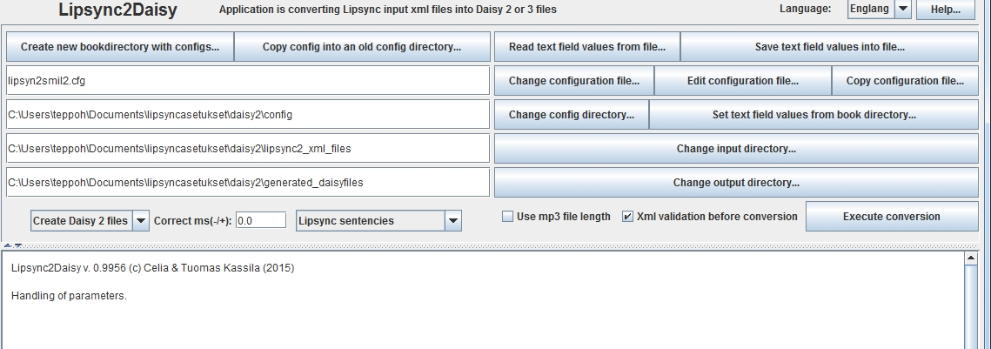
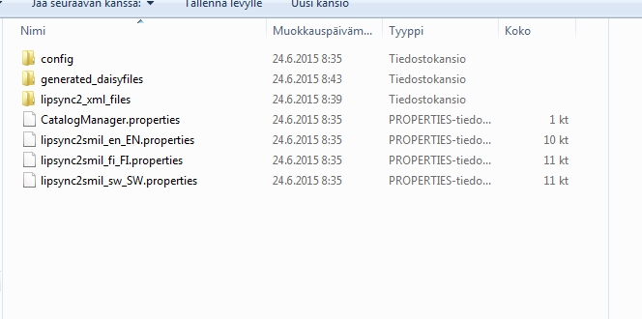
Lipsync2daisy instructions
dtbook (xml) to daisy 2 or daisy3
Terppo Huttunen
teppo.huttunen@celia.fi
Tuomas Kassila
tuomas.kassila@gmail.com

What you need:
Lipsync tool from www.annosoft.com
Lipsync2daisy java application (Celia/Tuomas Kassila)
Audio and Dtbook/xml files

foreword
When making Daisy2 or Daisy 3 fulltext/audio books, it requires a huge amount time and work. Normally by example every sentences must marked into a recording book. That's because sentences or paragraphs must be individually selectable by the listener of a daisy book. With Lipsync2daisy (open source) and Annosoft Lipsync tool (commercial) applications you save huge amount of time and work!
A first application, Lipsync tool, can synchronise text and audio files and produce xml data with word and times. A input text file can be a dtbook file text, which must handled. Second application, Lipsync2daisy is reading then Lipsync xml data and generates a daisy2 or daisy3 files together with audio files. Sentences or paragraphs are marked automatically as daisy sentences into generated daisy files.
Lipsync tool can sync XML code with audio file and export them as xml timesheet files.
Lipsync2daisy generates SMIL, XML, NCX, OPF and in case of daisy2 HTML files.
This is first short introduction of how to use Lipsync tool and Lipsync2daisy. Not every function/button is explained.
Workflow of handling a dtbook file
- Use Lipsync to produce xml time data after audio files and dtbook text
- Run Lypsinc2daisy application to produce daisy 2 or daisy 3 files by using step 1 files.

1. Use Lipsync to produce xml time data after audio files and dtbook text
Before Lipsync tool, prepare dtbook text into Lipsync application.

first chapter : Editing DtBook/xml file
- Delete <!DOCTYPE dtbook
PUBLIC "-//NISO//DTD dtbook 2005-3//EN" "http://www.daisy.org/z3986/2005/dtbook-2005-3.dtd"> from the beginning of the dtbook (because lipsync tool tries to sync it)

- Remove any other meta characters than DC. example <meta name="track:Guidelines" content="2015-1"/> or / and <meta name="dcterms:modified" content="2015-01-24T11:10:56+00:00"/>
(In this version of Lipsync2daisy 0.9956 they don´t generate right and cause problems when opening book/validation)
- Make sure that everything in DtBook is as it is in AUDIO.
If the page numbers are not audible in audio remove number after the page=”normal”> and before </pagenum> . Lipsync2daisy will generate number from the ID so you don´t lose them. if they are spoken you might have to add word PAGE before the number to get better sync in Lipsync tool.
Examples:
Original page number = <pagenum id="page-3" page="normal" >3</pagenum>
Spoken page number = <pagenum id="page-3" page="normal">page 3</pagenum>
Not audible page number = <pagenum id="page-3" page="normal" ></pagenu

- Make sure that the page numbers are always inside the ending level tag and not beginning of new level. (Smil files have to start with level start tag. if there is pagenumber first in smil it will cause errors in validation)

- If the DtBook/xml file includes Unicode characters change them. Lipsync tool don´t understand them.

second chapter : LIPSYNC TOOL
- Open first audio file of the book in Lipsync Tool.
- Open Edit -> Preferences and choose only SAVE WORDS, SAVE PUNCTUATION and SAVE USER EVENTS.

- Choose the language
- Copy / paste same Dtbook code as audio from the starting tag of level to the corresponding ending tag

- If audio is long you might have to use AUDIO CUT MARKER AT CURSOR from the EDIT menu or F4 and. (Usually I have to do this if audio file is longer than 20 minutes. I just listen some spot and and use FIND on XML editor and put the marker in place. I´ve managed to sync 2 hour long audio file using AUDIO CUT MARKER AT CURSOR.)
- Press LIPSYNC WITH TEXT or F7

- If Sync is ok choose FILE menu and EXPORT. Name the files with growing numbers starting from 1. Export format is XML. If there´s problem with sync try different settings from LIPSYNC menu. There also might be differences in DtBook/xml and audio.) Exported Timesheet should look like this:
- Do the same (as above) with the next chapter.
- When the whole book is done, you should have the list of exported xml files like 1.xml, 2.xml, 3.xml, 4.xml, 5.xml, 6.ml, 7.xml….

third chapter : Lipsync2Daisy

- Open Lipsync2daisy application with clicking two times lipsync2daisy.bat file.

- PRESS Create new book directory with configs. Choose either config or another directory and give name. This creates specific folder for the book.
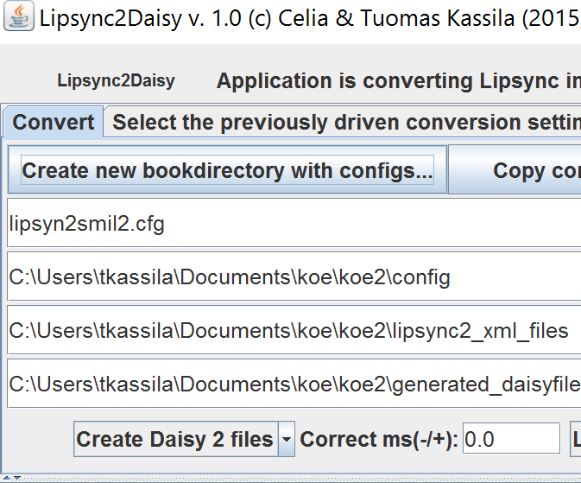
  - Then select where configuration files will be copied: from current configuration directory or from another directory (=select able config directory)
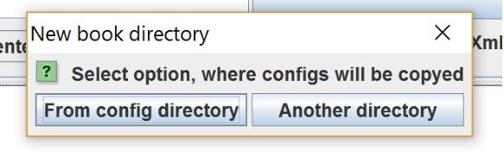

  - Select that directory where a new directory will be created
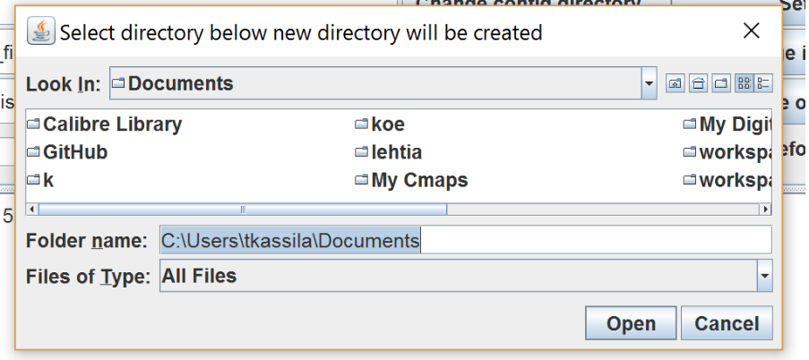
  - Write a name for new directory and press OK button
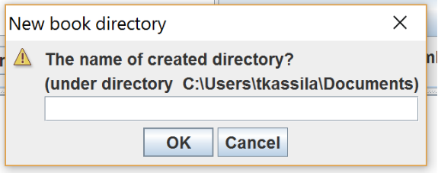
  - New directory with config directory has been created
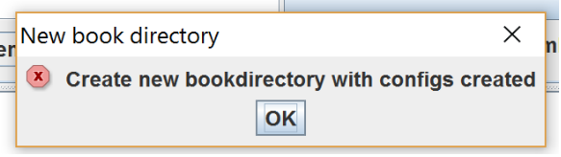
And a new content of text fields of the application has been updated to point just created configuration directories
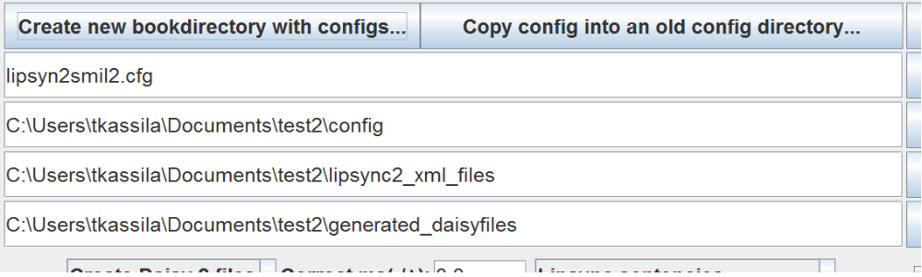
A directory ..\lipsyn2_xml_files is for xml files produced by Lipsync tool (usually 1.xml, 2.xml...) and ..\generated_daisyfiles are for generated files by this application and for those rest files produced by producer tool like 'PRS Pro': .mp3 audio files, book pictures etc.
- Choose Create Daisy 2 files or Create daisy 3 files
- Press Edit configuration file

DAISY 2 :
press SEARCH NEXT USUALLY CHANGED VALUE
dc_title= Write header for generated text document (optional)
dc_authrows= Writers names of the book etc with comman separated (optional)
page_lipsync_time_on_off=if page numbers are SPOKEN this should be off. if they are NOT SPOKEN then ON
change_xmlelements_startendtimes_between_wordelements= on/off (If page numbers are not spoken, in daisy3 they can´t have same beginning and ending time, in daisy2 it´s possible.)
doctitle_on_off=true

after that you might have to edit executetype=2 at the end of the window. Just put 2 (daisy2) or 3(daisy3)
and press SAVE
TIP
In Config -> daisy2templates is dtbookelements.cfg file. This is affecting how Lipsync2daisy converts some dtbook xml elements into html elements. Open it with some text editor (not with word or like that) and you can modify how you want lipsync2daisy handle certain elements. This only works with DAISY2.
Example. <list>==<ul class="plain"> means that <list> tag will be <ul class=”plain”> in generated html daisy 2 file.

DAISY 3:
Same as Daisy 2 but also:
in daisy 3 you also can change the smil names editing
smilbasefilename=

- CHOOSE Save text field values into file. You can save settings so you don’t have to go through all. Like DAISY2_nopages or DAISY3_pages_spoken etc.
- Copy all exported xml files from Lipsync Tool to lipsync2_xml_files to folder you have just created.
- Copy all the images, audiofiles (same files you used syncinc in lipsync tool), css files and other to the generated_daisyfiles
- Check the name of the audiofiles. With DAISY2 you should rename them speechgen0001, speechgen0002, speechgen0003 etc. In DAISY3 you have the option to choose the name in configuration file. Bottom line is that audio files have to have same filename as smil files. (you can do it quickly with programs like bulk rename here.)
- Press execute conversion. Lipsync2daisy starts to build Daisy book. If there is some errors you can try to find the causes of errors from the CONFIG folder -> VdTreeXml.xml. Or read from 'Some known issues/bugs' number 6.
- Open the book and test it in your daisy reader program. You probably have to do some HTML or XML file editing to make it better.

SOME KNOWN ISSUES/BUGS
- when generating DAISY3 you should have .res file on the root of the book and line <item href="tpbnarrator.res" id="resource" media-type="application/x-dtbresource+xml"/> in OPF file <manifest>
- dtb:depth don´t always generate right. it´s easy to fix in NCX file (daisy3)
- In validation there might be some errors in smil times. Usually reason is gaps between smil events. They are pretty easy to correct with regex or by hand.
- When making daisy3. configuration file change_xmlelements_startendtimes_between_wordelements turned ON might cause errors in validation. Reason is that it makes little difference in starting and ending time in SMIL event and the Smil event before might have bigger ending time than what is the next starting time.
- Lipsync2daisy don´t like if lines in xml timesheets are broken or if there´s emptylines. Example if pagenumber in original Dtbook is spreaded on two or three lines it´s usually will be exported from Lipsync Tool same way and will cause problems.
- If you have some xml validation errors in input text (=in dtbook) after “pressing Excecute button”, you can set off xml validation before Execution button and press again Execute button. Then generating files can succeed.
- Also “Use .mp3 length” -button may be not necessery set.
- If you have a high resolution screen on your computer, then you can change a default font size of Lipsync2daisy application before your start it. This done by modifying file lipsync2daisy.properties file. This file can be in two directories: install directory (=the same directory where .bat file exists) for common start. Another directory can be user specific directory, so called home directory. Also Os environment 'USERPROFILE' or Java environment 'user.home' are pointing to that directory. You can copy lipsync2smil.properties file into this directory. And then you can modify it into like those values, which are below.
Sample content of lipsync2daisy.properties
It has two cfg variables. Here is an example of a content, when this file has been modified, but you can change values, which are suitable to your screen:
# this is a comment line
# if this app is showing too smail fonts, because your screen has too high screen resolution,
# you can add font size with number, by example: addintofontsizes=13
# zero value does not do anything!
# And is good to add also: dividerlocation=430
# you can try different values to your screen and this application
#addintofontsizes=0
addintofontsizes=13
#dividerlocation=280
dividerlocation=430
TIP
When your editing many books, a next tip can be useful: In main window there is “Select previous driven conversion settings for the current” - tabbed panel. After pressing it, you can press one of left side button and set one of previously executed settings into the current settings. (When you want delete a book execute list row from this list, press one of right side Delete-button. It is deleting only this book mark row, not itself configuration files and directories.)
